
ZH-T420 Vertical pack machine
Operation Instructions
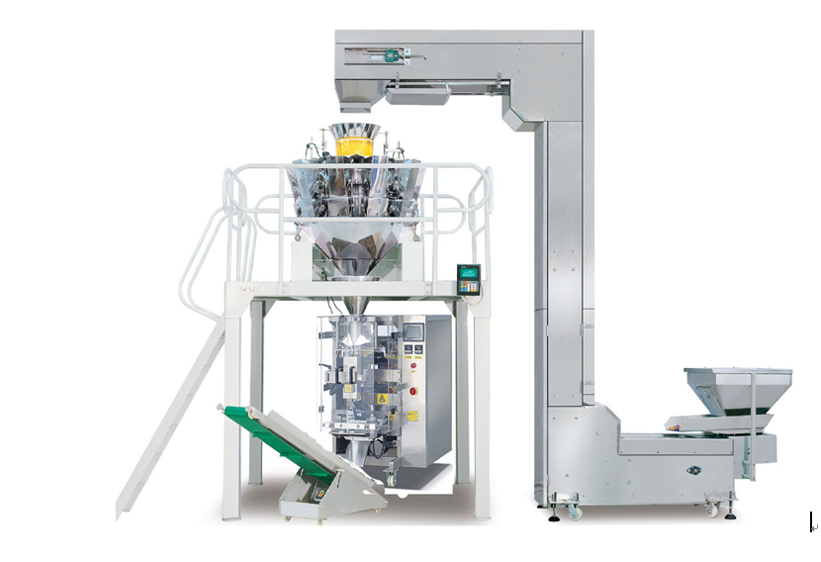

- Thank you for choosing machines from Jinan Zhuoheng Extrusion Machinery Co., Ltd.
- please read this operation instruction before using the machine
- Welcome to inquiry if anything unclear

济南卓恒膨化机械有限公司
JINAN ZHUOHENG EXTRUSION MACHINERYCo.,LTD
- Recapitulate
ZH-T420 vertical pack machine, which is manufactured with the worldwide advanced technology and soul, it has been developed serial years and been widely used in china and Southeast Asian.
This machine consists of relay winding, PLC program-control, touch-control, photoelectron control and digital temperature control. It has the functions which automatically complete bag making, estimating, filling, sealing, date-printing, cutting, workably disporting and joining.
These machine has the fine characteristics which are high accurate, reasonably constituted, easily handled and maintained. It’s a first choice of the packaging machine.
2. Features
2.1 Advanced design for complete machine, reasonable structure, convenient adjusting operation and maintenance;
2.2 Standard positioning with servo film transporting system; stable for transporting film with two synchronous belts;
2.3 High autoimmunization with auto correction function;* minimize the consumption with multiple kinds of auto warning protection function
2.4 Supported by metric device, the machine can automatically complete all packing processes from measuring, feeding, filling,

3. Range of configuration and picture
ZH-T420 vertical pack machine can be supported by auto weighing machine, meter glass dosing machine, manual batch conveyor and spiral dosing machine. It has an extensive range of package, suitable for packing of each kind of item such as grains, blocks, bars and powder, etc.

ZH-T420 vertical pack machine
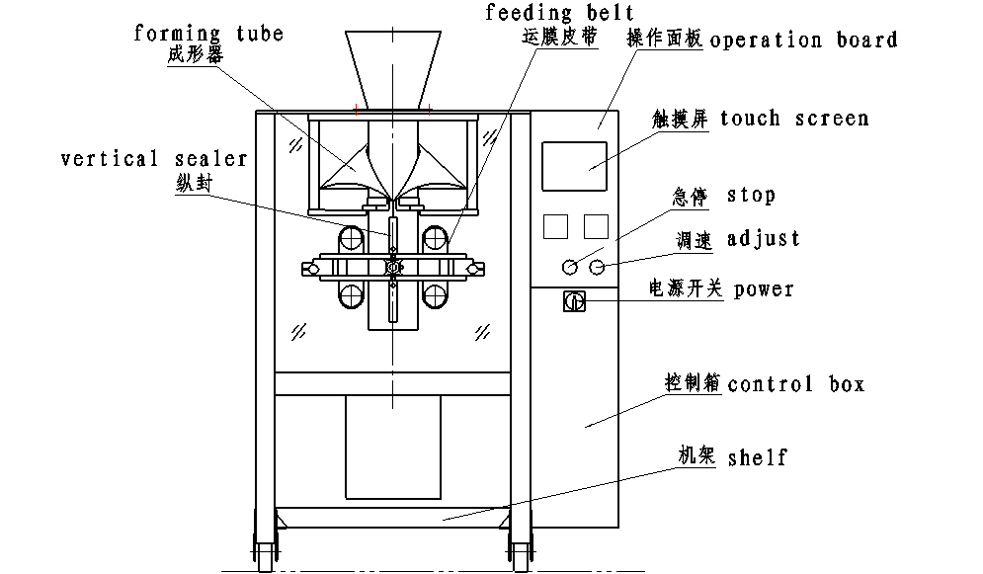
ZH-T520 vertical pack machine
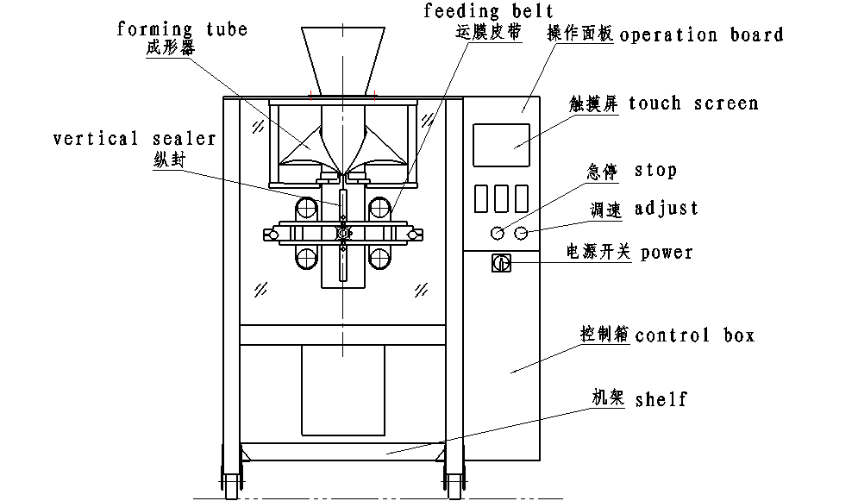

ZH-T720 vertical pack machine
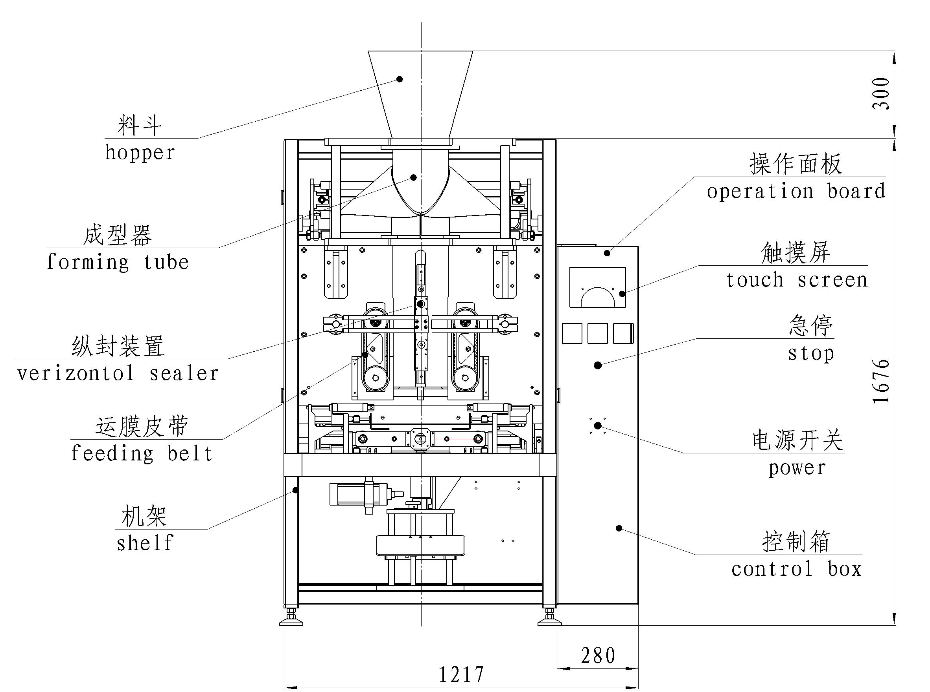

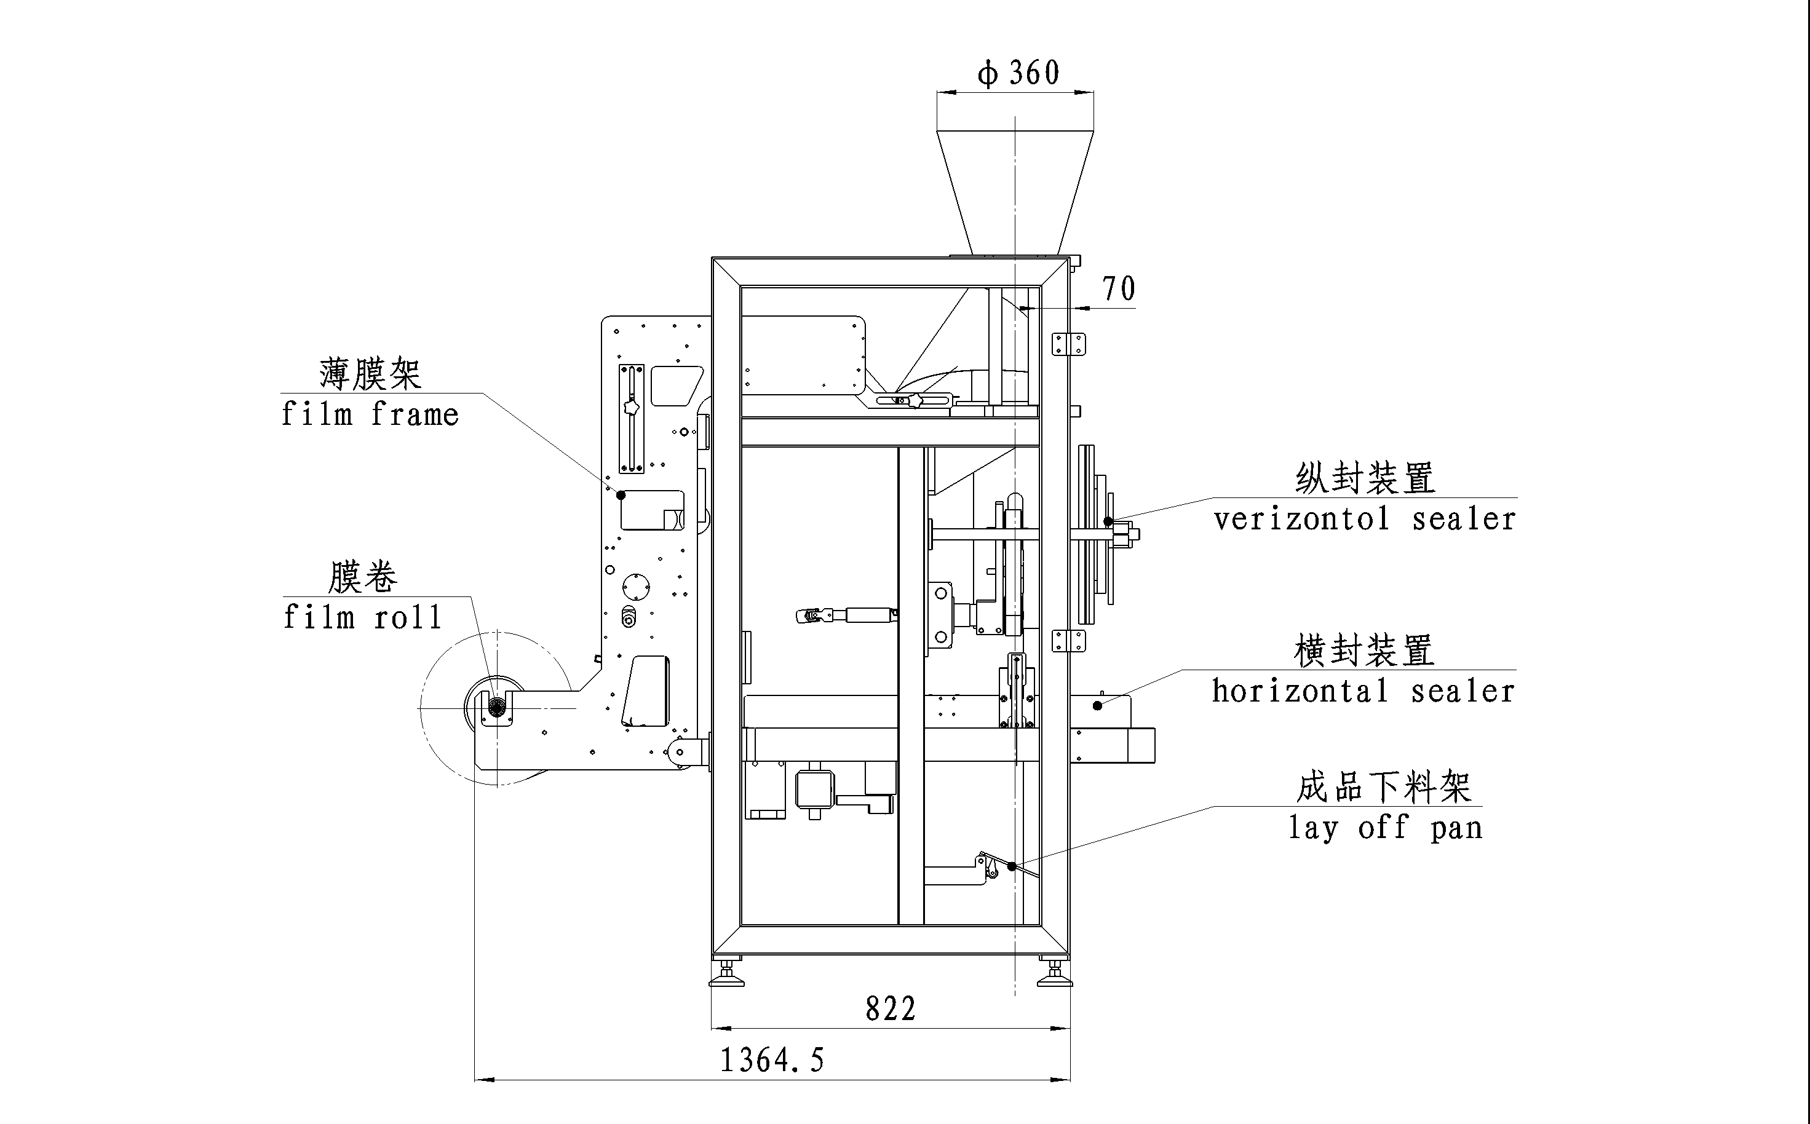

4.Technical specification：

Items | ZH-T420 vertical pack machine | ZH-T520 vertical pack machine |  | ZH-T720 vertical pack machine
Packing speed | 15-80 bag/min | 10-70 bag/min |  | 5-50 bag/min
Bag size | (L)50-300mm  (W)60-200mm | (L)80-350mm  (W)80-250mm |  | (L)100-450mm (W)100-350mm
Bag making mode | Pillow-type bag, standing up bag, hole punching device
Range of measuring | Max 1500ml | Max 2000ml |  | Max 4000ml
The maximum width  of packing film | 420mm | 520mm |  | 720mm
Thickness of film | 0.04-0.08mm | 0.04-0.08mm | 0.04-0.09mm
Air consumption | 400L/min 0.8×10⁵Pa | 400L/min 0.8×10⁵Pa |  | 800L/min 0.8×10⁵Pa
Main power/voltage | 2.2KW/220V 50-60Hz | 2.2KW/220V 50-60Hz |  | 2.2KW/220V 50-60Hz
Dimension | 1400×970×1700mm | 1430×1200×1700mm |  | 1780×1350×2000mm
The weight of switchboard | 450kg | 650kg |  | 800kg

5.Arrangement & operation
5.1 Arrangement the machine
You must adjust the four bolts which on the machine bottom, be sure the machine on the horizontal line.
5.2 Power supply
AC220V（±10%）、50-60HZ、3KW unilateralism electric power.
Attention: Triangular must kiss the ground.
6. Explain & operation
  - Film shelf
Explain: Film shelf is used in the packing film, push the film into the framer.
Operation :(i) Film arrangement: measure the film width size, and according to the ruler move the fixture, screw down the film. Show as the following:
Film goes into the framer: The film be cut as triangle, inserted the framer. When (ii) change the second roll film ,you can direct to the fore and after end film face to face the pattern ,then use exhibit strip to cling it start machine and pull in the former.
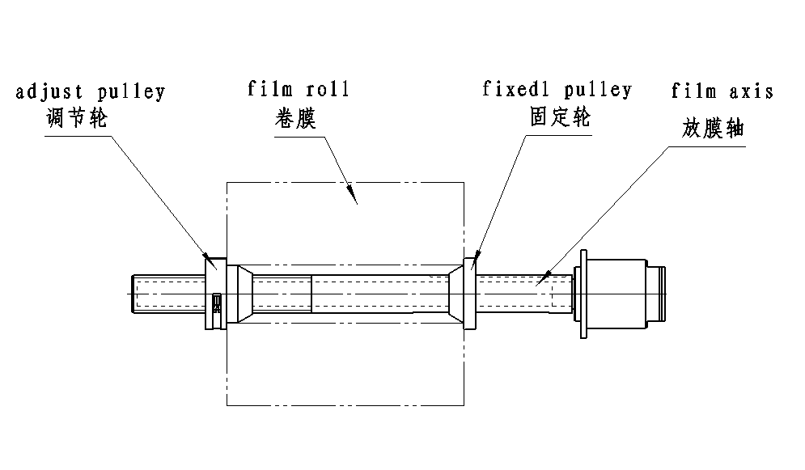
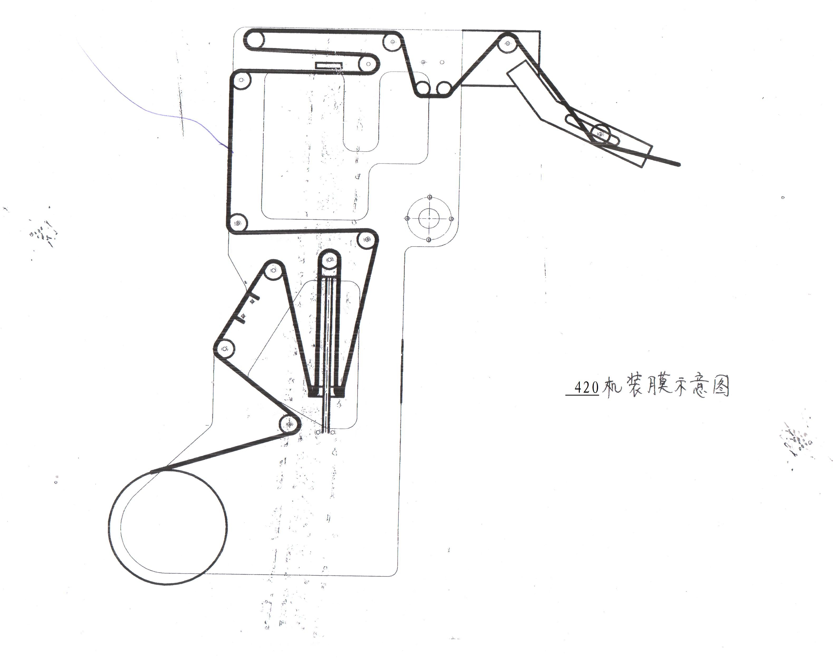

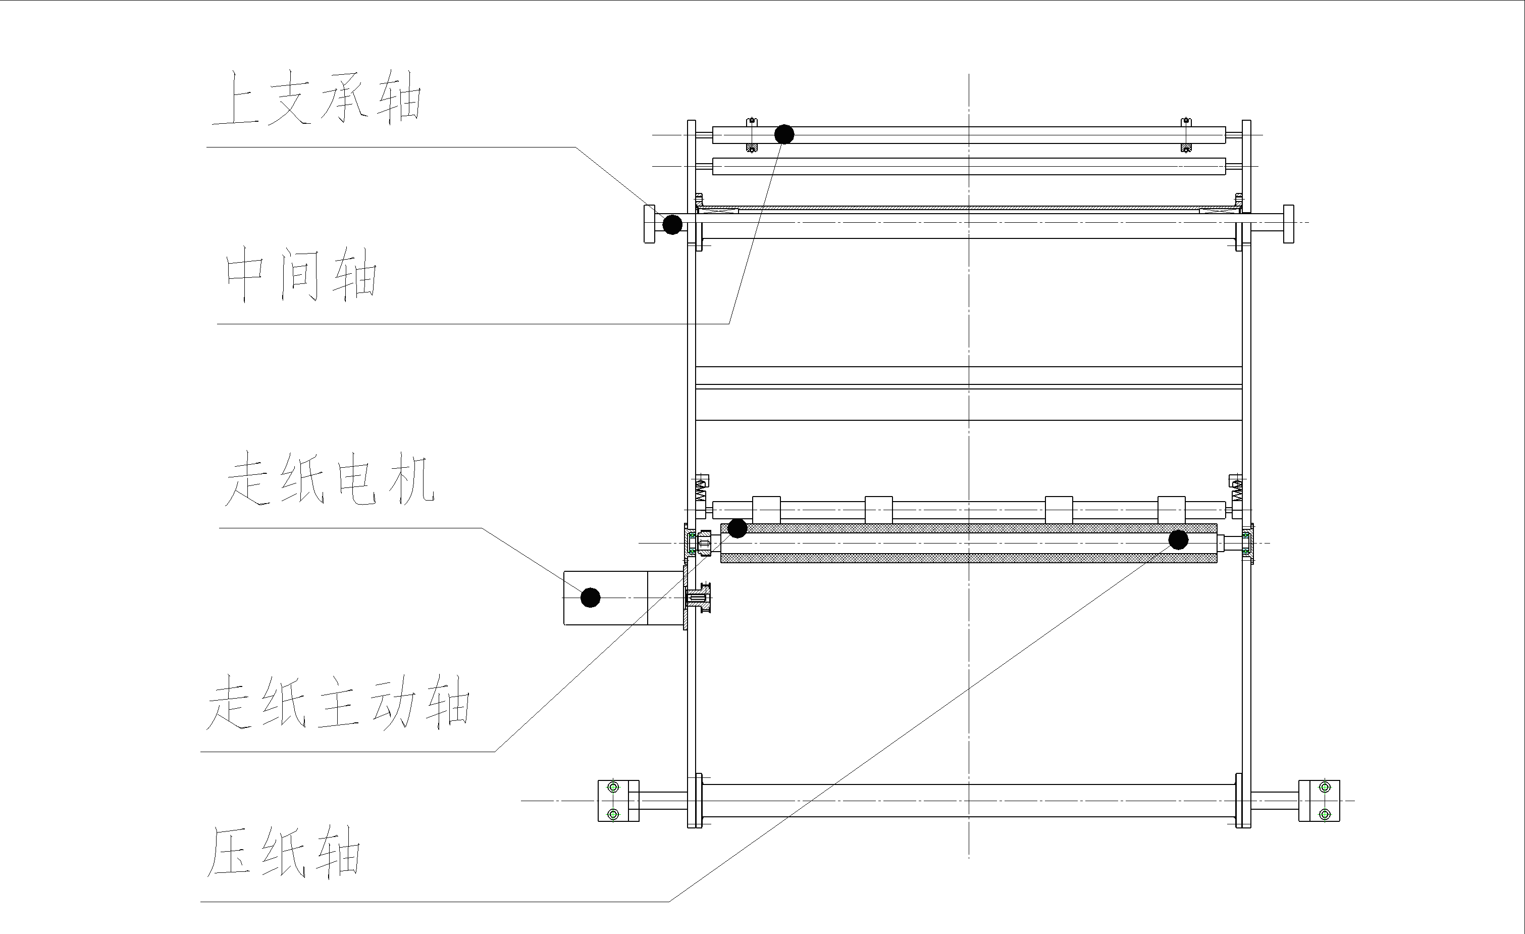

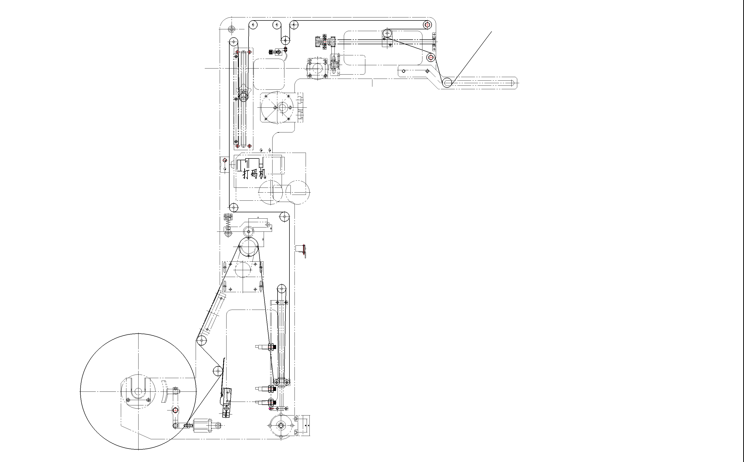

ZH-T720 vertical pack machine
6.2Printer
Explain:
Operation：(i) install the black ribbon: According to the old date printer to change the ribbon .
(ii)Change date: pull the type of handgrip inside(1.5~2mm).At the same time, the handgrip be turn around 90º~180º,be come away the crook. Pull out the type. Then change the type. Attention: no deflection. Don’t beat the type with metal in the case of mangling the type.
(iii) Print place：Turn around the printer’s hand wheel which is on the printer’s side face .Be sure of the horizontal print place. Move the film roll to front or back .Be sure of the vertical printer into place.

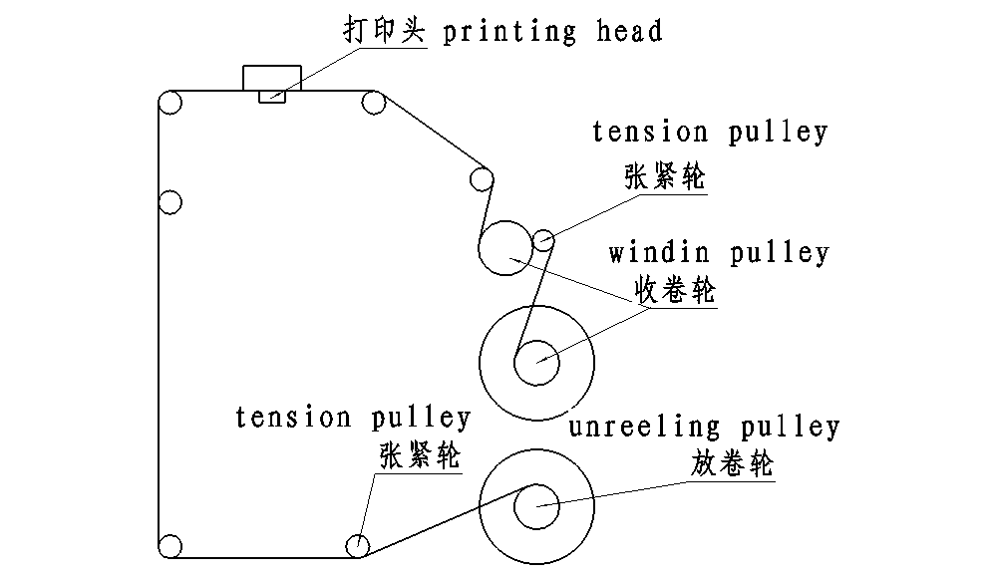

6.3 Adjust & sensitivity
a. Photo electricity explains: It is use in the color specification, be sure of the cutting place.
Operation: loosen the photo electric’s hand wheel Moving ray aim at the film color specification.
Show as the following：
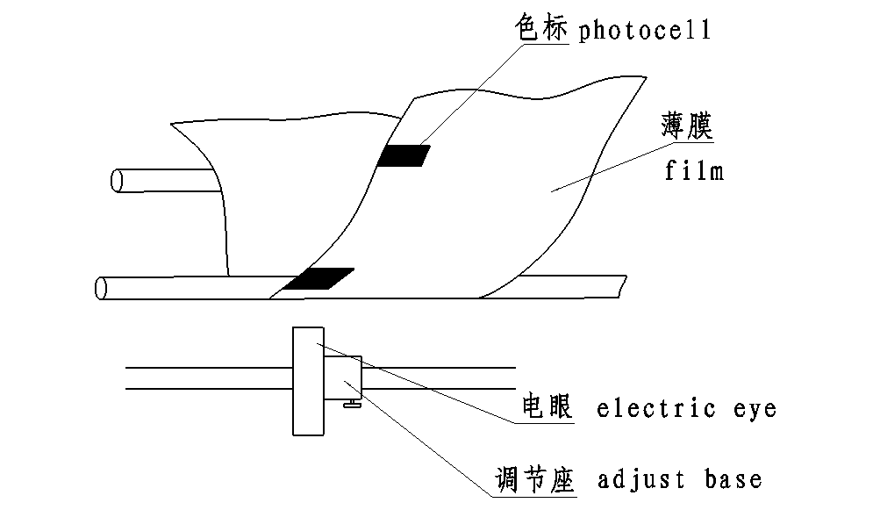

Adjust the photoelectric eye
Explain：Not all the photoelectric eye can test the color specification, because the customer’s film is different form the factory’s .So you need to adjust the photoelectric eye’s data.
Operation：At first ,move the ray to the film’s color ,(no the color specification)distance the film about 4-5mm.Then put the magnifier’s switch to “SET” key, press the “off” key no detect aim . Move the color specification to the ray , at the same time press the “on” key . Turn the magnifier key to “LOCK” key after adjustment.
6.4 Press adjust
Explain：The film’s traction controlled by the feed belt’s friction, the friction controlled by the compress air press.
Operation：Pull out and turn around the valve, look at the barograph’s air pressure. It is about at 3kg/cm². Assure the machine work as usual.

7. Control box
7.1 The operation board show as the following attar electrify：


7.2 Homepage shows:
Choice the language: For example: If press the “English” key , it will load into English phase.（show as the picture 2）
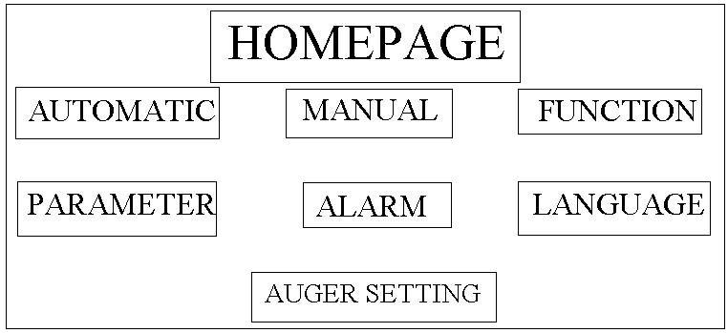
Press the “Automatic” key , load into work phase（show as the picture 3）
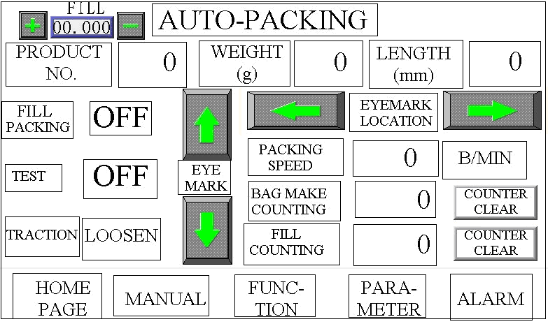
“Automatic”is the main menu of the work phase, In the course of nature open the boot strap,the machine will show as the picture.
Press the“MAKE ONE BAG” press the key, The machine produce a empty bag.
Press the “TEST “key” , adjust the empty bag.
Press the “TRACTION” key, the machine normally works with the mulithead weigher.
Press the “stop” key , the phase of “TEST ”or “FILL BAG” would stop,

“TRACTION”press the key ,feed belt press up ,then the key show“close”. Press the key again ,feed belt loosen,the key show“open”.
Press the key：potoelectricity’s shelf move to back, the color specification’s place move up.

Press the key： the potoelectricity’s shelf move to front, the color specification’s place move down.
Press the key：film shelf turn left, adjust the film go into the framer .In the case of the right more than the left.

Press the key：film shelf turn right, adjust the film go into the framer. In the case of the left more than the right.
Another the “Automatic” shows the produce number|, net weight, bag’s long, practice speed ,counter ,homepage, manual, function, parameter and alarm.

7.3 Manual：（show as the picture 4）
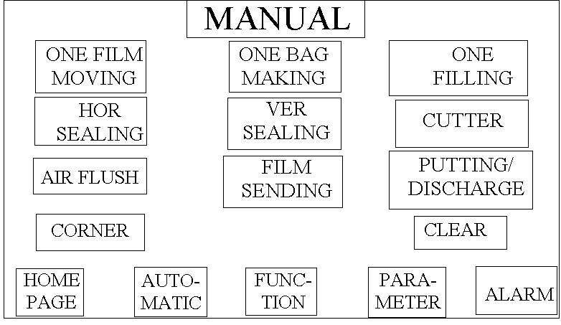
“ONE FILM MOVING ”press the key, the film work once but not the horizontal、vertical、cutter.
“MAKE ONE BAG” the same as the automatic, we don’t narrate any more.
“ONCE FILLING” press the key, the multihead weigher work once, but not the packing machine
HORI.SEAL, VERT.SEAL, CUTTER, AIR FLUSH, FILM PULL, FEEDING, GUSSET, functions in the “manual” page all of bnem can be opened or closed.

  - Function: Press the key, load into the page. （show as the picture 5）
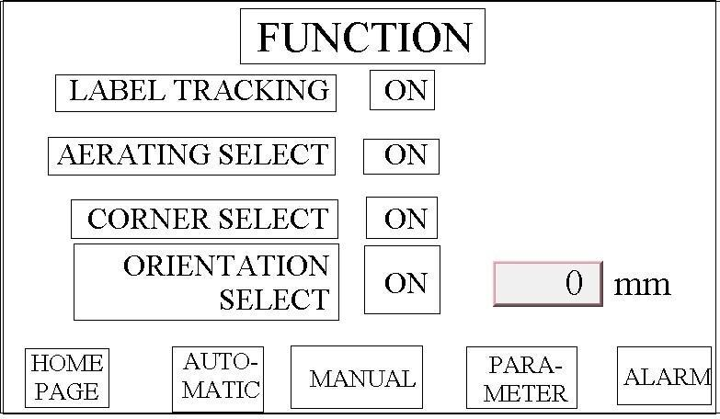
Photo electricity: Attention: setting bag length must more than the border upon color specifications. If it is “off” key, it use to the film which no color specification. We need setting the length.
Aerating：It shows that air fill is “on” or not is “off”.
Folding：It is “on”, the insert working.

7.5 Alarm（show as the picture 6）

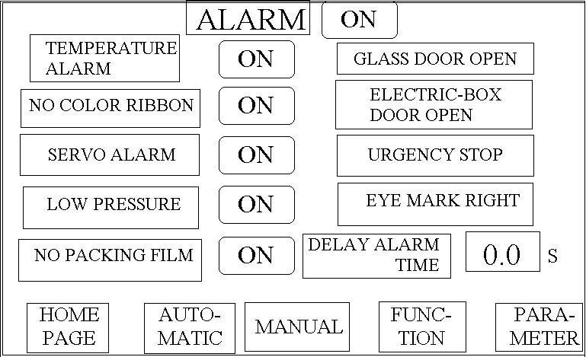
The alarm setting with “on” key. Set up your need alarm being “on”. If it show the alarm clew for example“temperature、no film” and so on .The machine will stop working. You must settle the problem as soon as you can. Then press the “reposition” key. If the machine also cannot work, you must clean all the alarm .All the alarm cut no ice if the “alarm setting”is “off” ke
  - Parameter setting（show as the picture 7,8）
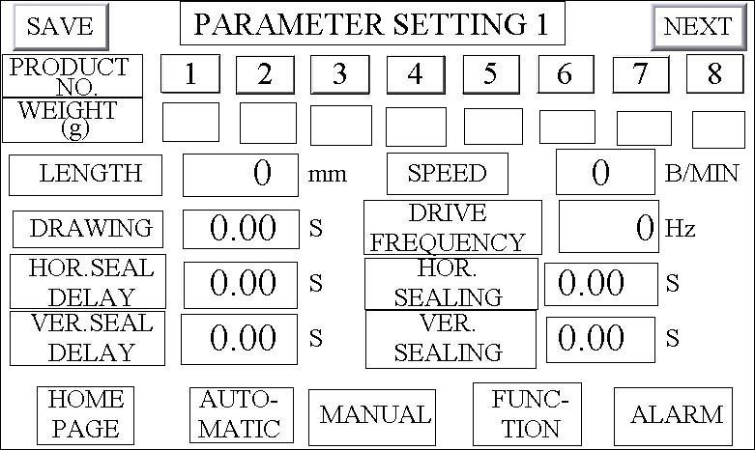
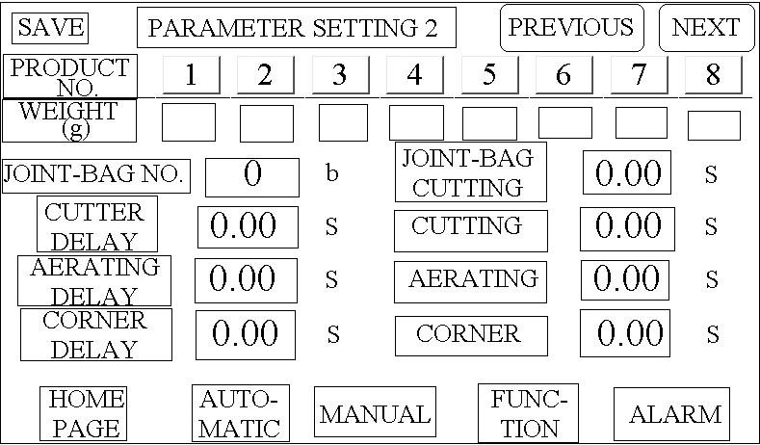
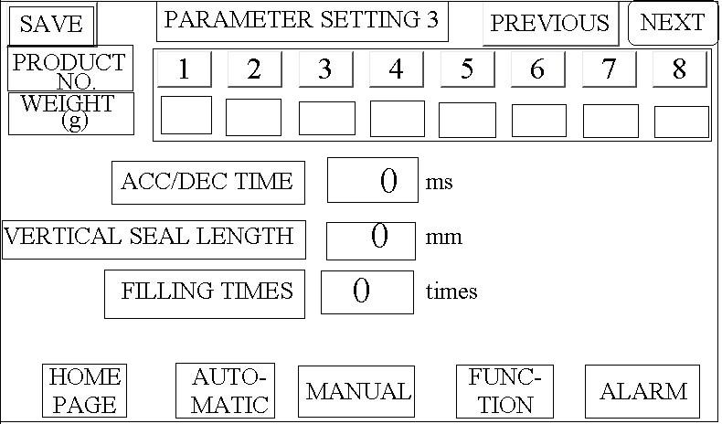
Load into the page, choose the production number, the counts are 1-8.
produce No、net weight、bag length 、speed、all sealing、According to the product’s specifications to serial number, Save the parameter.
Setting each work time：
Hori. sealing：0.50S—0.85S Ver. Sealing : 0.50S—0.85S
Aerating delay： 0.14S—0.20S Aerating：0.10S—0.18S
You can according to the produce assure the speed and other.
cutter delay：0.36S—0.40S cutting：0.20S
folding delay：0.20S—0.40S Folding：0.15S—0.35S
drive frequency: Servo motor is Simons 28000
Servo motor is Panasonic 5800
ACC/DEC time: 50 Ver. Seal length: 360-420mm Filling times : 1
Moving film：0.30S—0.50S , It is use in the manual pull material . Press the “save”after setting your need parameter. If no, the parameter became “zero” in the next boot-strap

This operation page for packaging powder
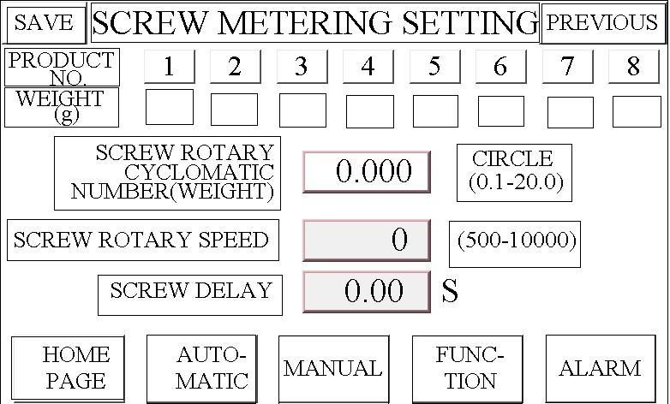
8. Change and maintain damageable parts
1. Changement
The main damageable part is traction film strap. If find the putting paper skid or strap has rub out .You should change strap .At first back out outside shell, screw loose M12 nut, running M6 screw to make the up strap wheel axes to move down. Loose strap to take out and change new strap when install strap .Pay attention to the strap neither too tight nor too loose.
2. Maintain
Be sure that the machine works as usual, operation worker must attention:
a.)Everyday finish the work, you must clean the machine. Use the Constringent air clean the flour which on the equipment. Use the cupreous brush clean the material which on the horizontal or vertical.
b.) Film framer clean as usually as you can. Make a mark before you disconnect the film framer. Setting as the original place after cleaned .The cutter used for a long time, you must disconnect it ,then attrition or change the cutter.
c.) the machine stop for a long time, you must cut off all of the power before clear the machine .You must have a test before plug in power.

9. NORMAL FAULT AND WASH DOWN
fault | cause | How to do that
Touch on ,the machine didn’t work | Check the emergency off | Reset the emergency off
Fuse blown | Check the beater | Check all of the electricity
Packer don’t heat | - Fuse blow  - Heater fault  - Temperature control watch fault | - Wash down the fault  - Change the heater  - Change new one
Temperature control watch number throb | Thermocouple fault | Change new one
Begin run, control watch number throb | Voltage too low  Heater plastron too low | Decrease the winding speed or increase the voltage to the normal
Bag packer chink | - Temperature too low  - Stress too low  - Packer time too short  - Pacer lumpy | - Ring up the temperature  - Increase stress  - Increase time’s parameter  4、adjust parallel ism.
Out of control point of tangency | - Web draw or failure movement  - Censor not in the right place  - The length of bag too short | - Change web  - Adjust sensitive of censor  - Increase the length of bag

